Programming ATtiny85

Arch Linux: Fix communication problem CH340

Module for CH340 is loaded dynamically. To check if loaded run command:
lsmod | grep ch34

output:
ch34x 36864 0

To verify run command:
sudo dmesg -wH

Should out put:
[ +1.697486] usb 1-12: new full-speed USB device number 19 using xhci_hcd
[ +0.124339] usb 1-12: New USB device found, idVendor=1a86, idProduct=7523, bcdDevice= 2.64
[ +0.000016] usb 1-12: New USB device strings: Mfr=0, Product=2, SerialNumber=0
[ +0.000006] usb 1-12: Product: USB Serial
[ +0.003202] ch34x 1-12:1.0: ch34x converter detected
[ +0.000688] usb 1-12: ch34x converter now attached to ttyUSB0

For driver bugfix install https://aur.archlinux.org/packages/ch34x-dkms-git:

yay -S ch34x-dkms-git

Programming ATtiny85
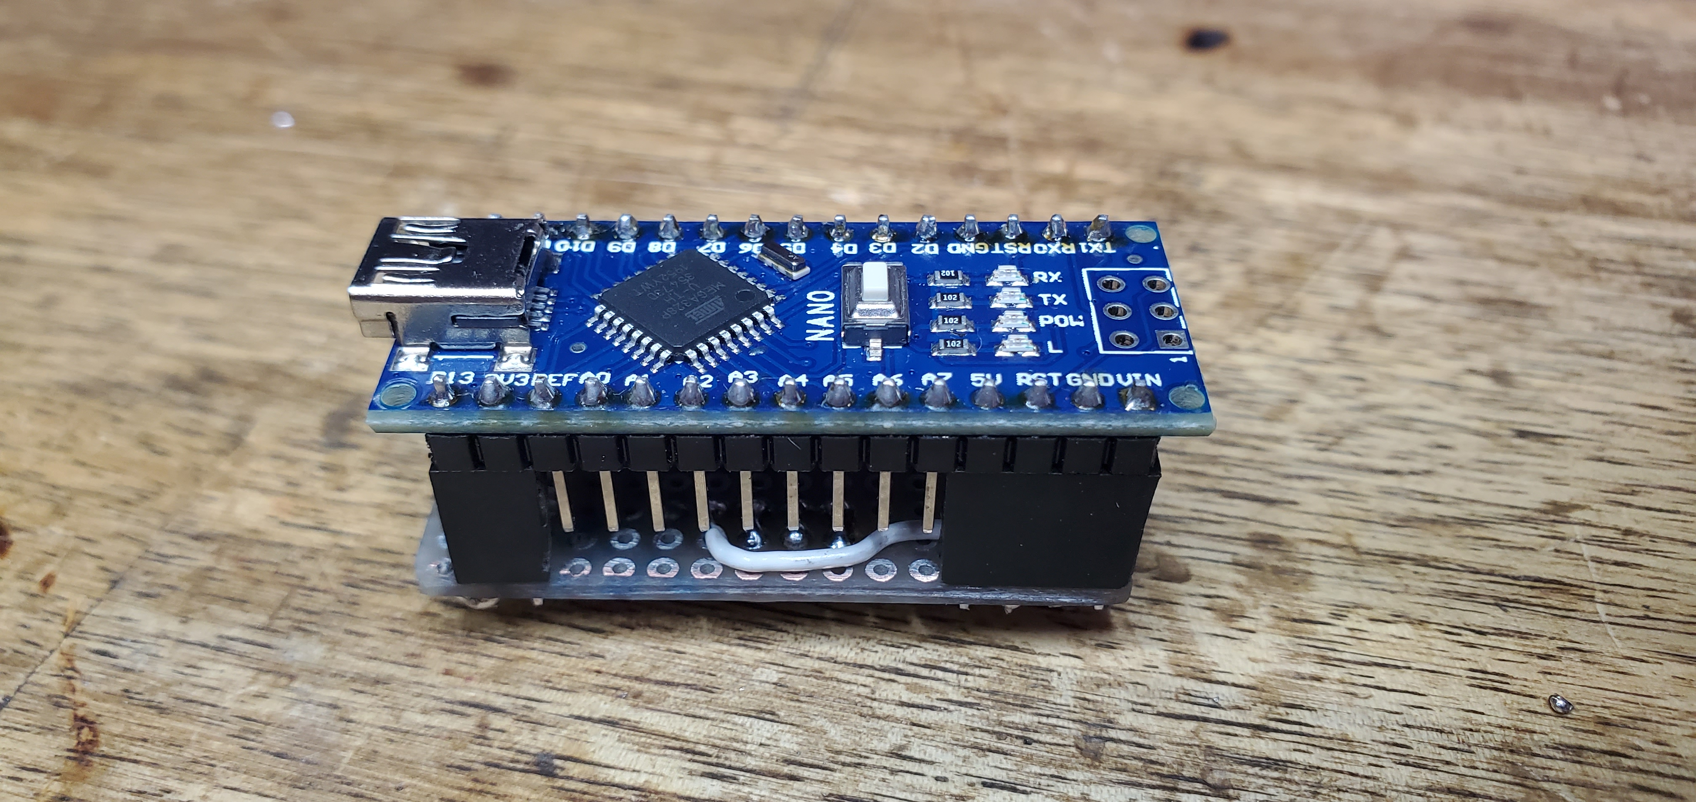
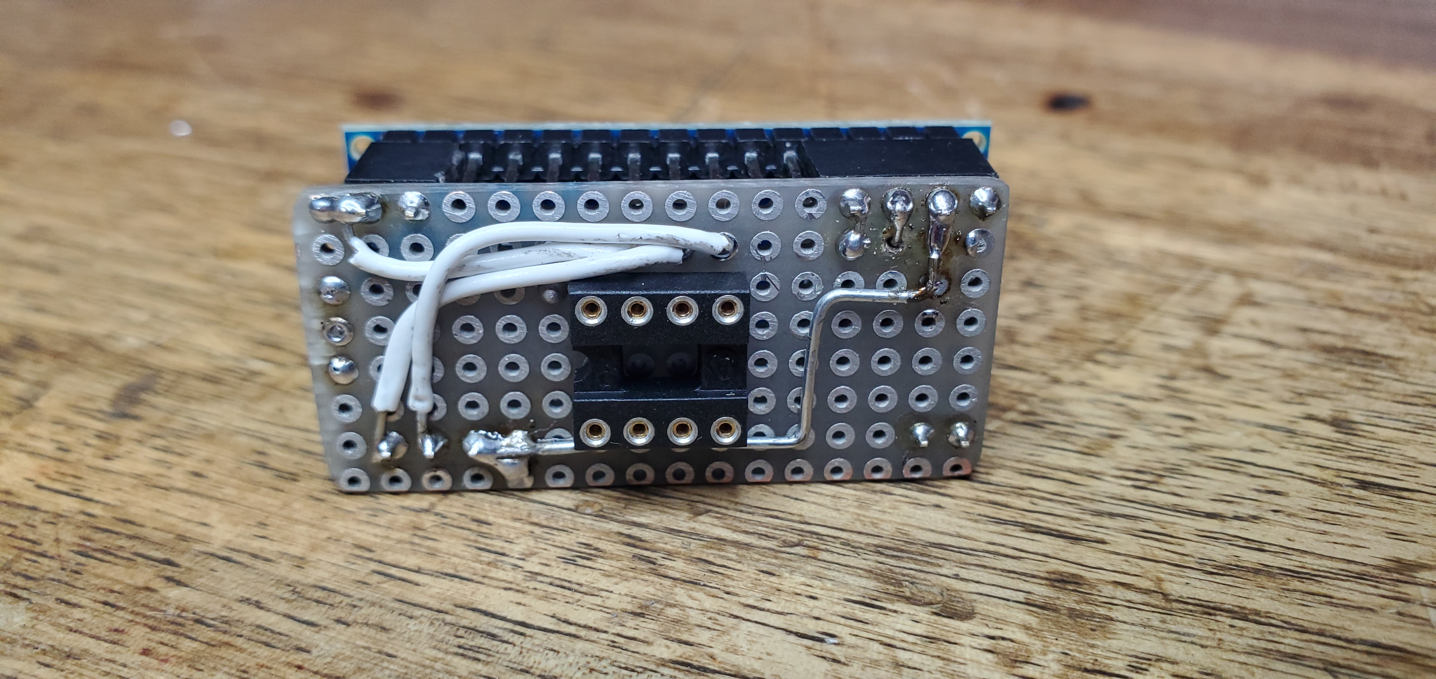

Arduino NANO as ISP programmer
Open the serial port of the Arduino it resets the device. That includes when the serial port is opened by avrdude for programming.
You need to prevent that from happening, so that the ArduinoISP sketch receives the serial data, not the Arduino's bootloader.
There's a number of ways of doing that:
- Add a 10uF or greater capacitor between RESET and GND on the Arduino
- Add a small (say 100R) resistor between RESET and 5V on the Arduino
- Cut the RESET-EN trace on the underside of the Arduino

